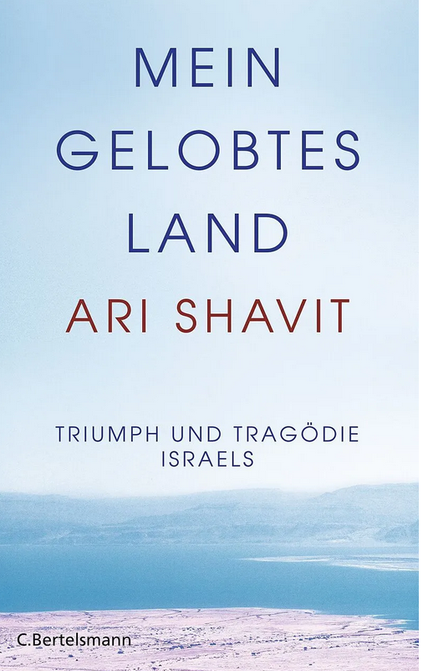

https://www.exlibris.ch/de/buecher-buch/deutschsprachige-buecher/ari-shavit/mein-gelobtes-land/id/9783570102268/?utm_source=google&utm_medium=cpc&utm_campaign=Performance+Max+CSS+Zombies+B_1+%26+B_2+(pm-CH-de)&utm_content=&utm_term=&gad_source=1&gclid=EAIaIQobChMIk5jjmummiAMVcbVoCR0oUg-2EAQYASABEgKCXvD_BwE